Create an Engaging LinkedIn Business Page
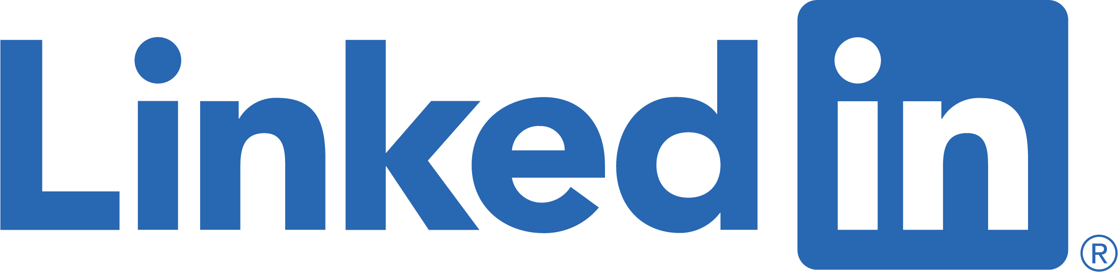

LinkedIn isn’t just for finding a job. Your business can reach prospective customers on LinkedIn. Many people on this business networking platform say they are likely to buy from a company they engage with on LinkedIn.

Create a business page

If you don’t already have a LinkedIn business page, set one up. It’s free to do so! You just need your own LinkedIn page and from there you can easily set up a business page. I recommend that you set this page up yourself and not have an employee set it up. I’ve seen too many business owners struggle to get control of their social media pages from a helpful employee that set up the page and has left for another job.

Write a compelling company description

You have 2000 characters to tell your story and define your brand. Let your followers know who you are as a company, what your products or services are, and share a little of your background story. Keep in mind to use your keywords so when people search for a business like yours, your business shows up high in the search results.

List your specialties and strengths

You can share 20 skills that describe your business and make it easier for LinkedIn users to find you in searches. Share them in this list section.

Include your logo

Put your logo in the profile picture area. Companies that include their professional logo on their LinkedIn business page get six times more traffic than those that don’t include a logo. To fit in the LinkedIn profile image section, your logo must be a size of 400 by 400 pixels.

Use a great cover photo

A great cover photo will attract visitors. You can use your cover photo to summarize your company and market your best product or service. Your cover photo should be 1,536 by 768 pixels to fix in this section.

Link your website and other social media

An effective online presence requires transparency across all your communications. This means you should share a link to your website and other social platforms, such as Facebook and Twitter, on your LinkedIn page. This allows prospective customers to visit these sites to learn more about your company.

Share content

Hopefully, you have a blog on your website. Blogging sets you up as an expert in your industry. Don’t just post your blog to your webpage. Share it on LinkedIn too. This expands your audience reach.

Use your LinkedIn business page to share information such as introducing new hires, case studies, and even industry articles.

About the Author:

Laurie Enos is the Director of Communication and co-owner of Blue Lilac Marketing Group LLC. She helps clients in multiple industries with their blogs, social media, public relations, and website design. Laurie can be reached at Laurie@BlueLilacMarketing.com.

