5 Phases of Project Management
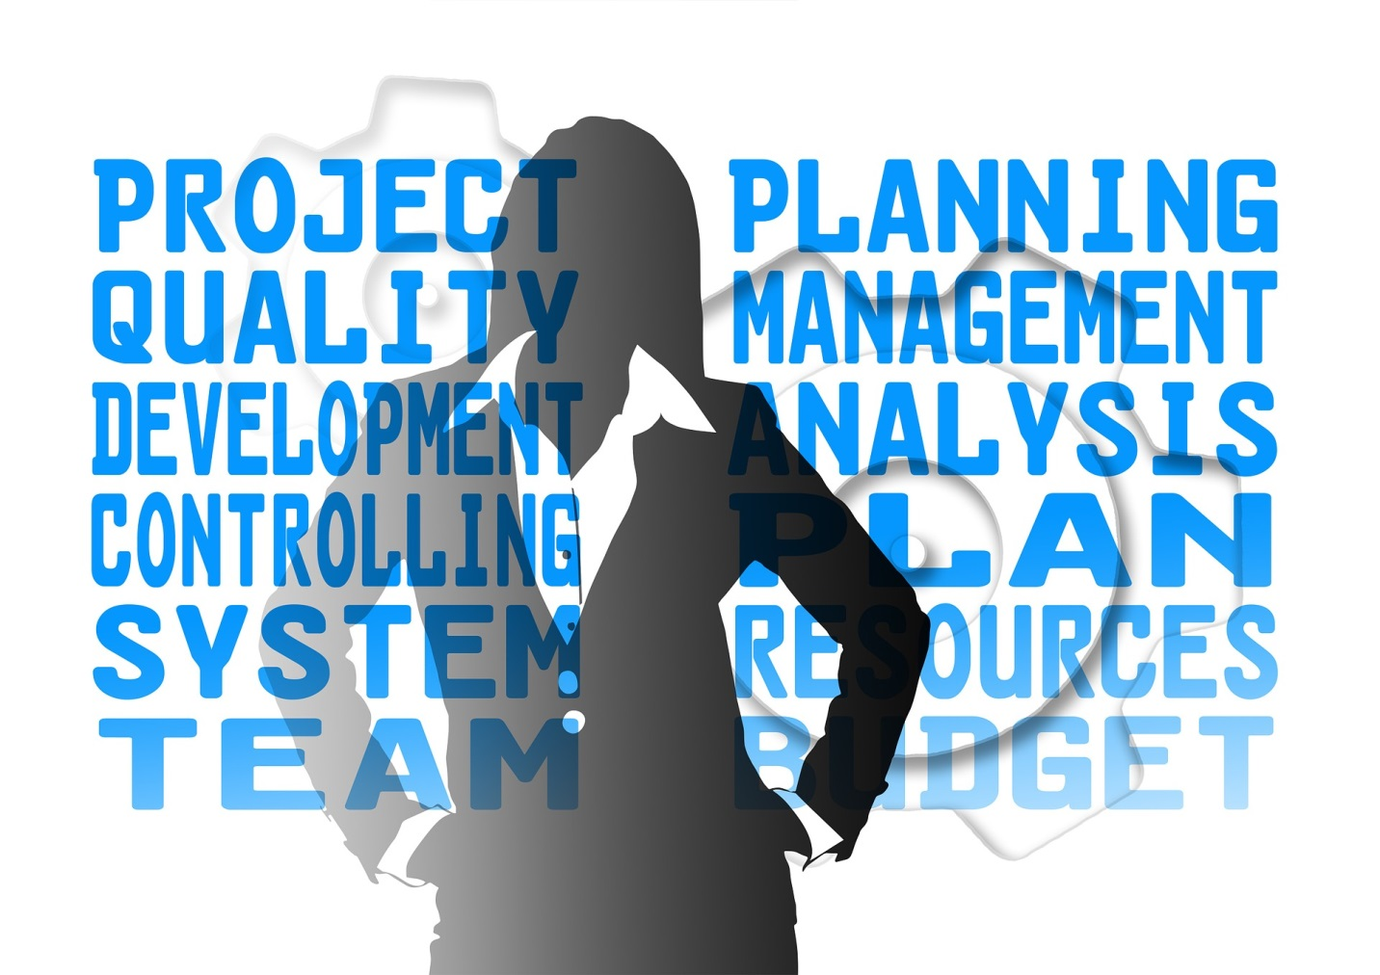
There are five phases of Project Management. These phases ensure that you adequately cover all the bases needed to successfully complete a project.

Initiation
Every project should be driven by a need. Are you trying to solve a problem, does something need an improvement, is something costing too much money now to build, and so on?
The need for your project can be proven by various methods. You can:
- Do a feasibility study
- Develop a business case
- Determine the project’s return on investment (ROI)

Planning
A project plan needs to be put together by the project manager. This project plan will be revisited throughout the life of the project to ensure that objectives are met.
- There needs to be a written scope statement. This reiterates the need for the project, and its deliverables and objectives.
- The tasks, or deliverables, involved need to be identified and broken down into their various pieces.
- A schedule needs to be identified for all the tasks and their dependencies. This schedule helps ensure the project is completed on time and on budget.
- The cost, or budget, of the project needs to be identified.
- Quality objectives need to be identified. The quality objectives may be stricter if the end product is a military device, a medical device, or a device that has to operate in extreme environmental conditions.
- The project team needs to be identified and have the necessary skill sets in order to make the project successful, depending on the type of project you’re pursuing and the needed outcomes.
- The organization and its staff need to be identified.
- The communications and progress reporting structures need to be identified.
- The potential risks and avoidance measures need to be identified.
- A procurement process for supplies and materials needs to be identified as well.

Execution
The execution phase of the project begins after the project planning is complete. It is up to the project manager to administer the project plan and its associated contracts. Various tools are used during the execution phase, such as a project dashboard.

Monitor & Control
The project plan, and its progress and adjustments, need to be monitored to ensure the desired outcomes are met. These include the following:
- Reporting
- Scope
- Schedule
- Cost
- Quality
- Risks

Close
The final phase of the project is the project close. The project manager needs to ensure that the scope and all the project deliverables have been met.
A Lessons Learned session should be completed to determine what was done well and what improvements could be made in the future. This session needs to be documented.
All the contracts and administrative matters need to be completed. All project documentation, including the plan, schedule, and Lessons Learned, needs to be disseminated to the proper parties and then archived. This project documentation can be used in the future to guide the work on similar projects.
Information about the individual phases of project management can be covered in future blogs. If you have any questions, please feel free to contact me.

About the Author

Sandra Glanton is the owner and managing consultant of Projects Accomplished! She spent 12 years as a Cross-services Project Manager on various product programs for a local multinational corporation. She can be reached at sg@projectsaccomplished.biz or (585) 230-0649.

