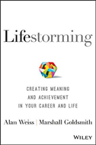
Lifestorming

The Science of Creating High-Performance Companies

By Paul J. Zak
Why do you do the things you do … and how can you do them better?
Lifestorming is the product of acclaimed executive coaches, Marshall Goldsmith and Alan Weiss. They help you understand why you do what you do and offer a comprehensive process that helps you do things better and create a new, improved version of yourself.
"Lifestorming is well-written and very informative. These lessons have an instant impact and will definitely help you grow professionally and personally." - The Association of MBAs

Video MP3 Phone PDF

iPad Web M Sticks Kindle

