Project Management and Communication
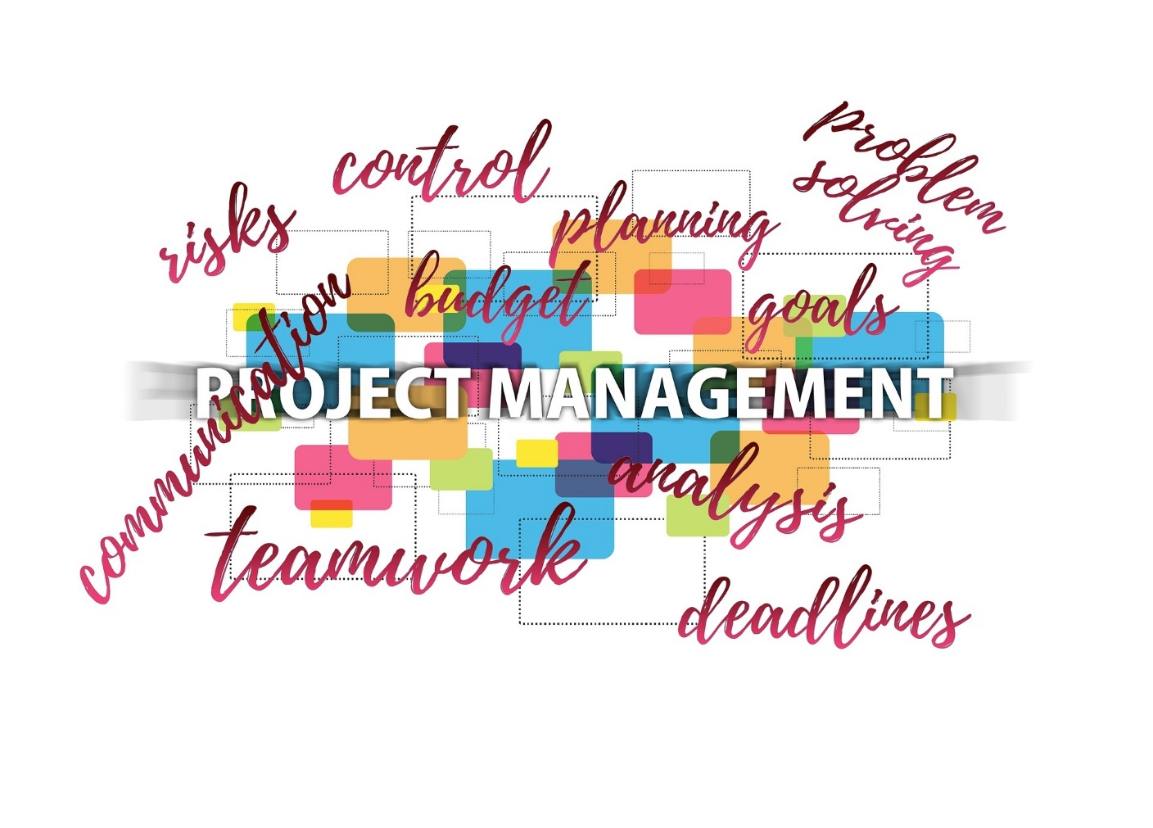
Effective communication is valuable in any relationship, whether it is a business or a personal relationship. If you are a project manager working with a team on a project, frequent effective communication is even more crucial than the communication in many other business relationships. In fact, some would say that “communication is arguably the single most important task”¹ you have, aside from the project management.
A project manager, particularly a cross-services project manager, may have relationships to tend to with stakeholders, clients, other project managers, developers, and suppliers during the course of a project. Each of these relationships carry communication responsibilities with them.

Stakeholder
“In business, a stakeholder is any individual, group, or party that has an interest in an organization and the outcomes of its actions.”²
For our discussion in this blog, stakeholders are anyone who has a financial stake in the project. In my experience at the multinational corporation where I worked, the stakeholders were the organization or group that was in charge of the product we were working on. They were responsible for the product from its development through its end-of-life (EOL) strategy. They were the group who set the product’s budget each year.

Clients
The clients are the primary customers of the Project Manager’s outputs. In my case, the Product Delivery Team (PDT) was my client. The PDT also set the schedule for our product’s overall delivery, at least in that launch cycle and likely during any and all follow-on launches.

Other Project Managers
A cross-services project manager may have several other project managers, and their schedules, to consider during the life of the project. In these days of trying to do more with less resources, cross-services project managers and the other project managers they’re interfacing with likely have more than one project they’re working on at any given time.

Developers
Developers can be software developers on the product program. They can also be translators, documentation developers, or training developers that the cross-services project manager is interfacing with directly or through the various individual project managers. All of these groups’ needs have to be taken into consideration for schedule and budget.

Suppliers
Vendors and other suppliers may be part of the mix on the project as well. This is possibly another group that the cross-services project manager needs to take into consideration during the development of a product.

Ways a Project Manager Can Facilitate Effective Communication

Be Present
“As a project manager, you set the tone for your entire team, so one of the most important parts of successful communication is being present. Be the type of manager that is readily available and that has a clear understanding of your team’s roles, challenges, and achievements. If you communicate from a distance and constantly rely on indirect forms of communication (like e-mails and voicemail), then you’ll foster an environment of passive communication between your team and clients.”³

Use Project Management Tools
The use of various tools, such as a detailed and comprehensive schedule, leave no doubts in the mind of your team, clients, or stakeholders on who is expected to complete certain tasks, what those tasks are, and when they are expected to be complete. You can use applications, such as Microsoft Project or Microsoft Excel, to develop the schedule. I recommend that you keep the schedule up-to-date at all times and ensure that all those who are responsible are on distribution.

Adopt a Communication Plan
You should have a communication plan in place from the start of your work together as a team on a project. This will determine how often the team and you meet, what is the purpose of the meetings, what type of status you and others involved will need from these meetings, and so on.
This communication plan does not take into consideration the other meetings that the software development team may be having with the translation team or the documentation and training development teams. Those groups need to meet and get things done with one another in order for the cross-services project manager to get a weekly status report pulled together for the PDT.

Schedule Meetings
I found that weekly status meetings, however brief, were necessary. These meetings ensure everyone on the team is on the same page as far as our progress. It also gives the various groups time to ask one another for handoffs that were needed. Part of my job as the cross-services project manager, was to listen and facilitate any deliveries that might be lagging.
These meetings could be 15 minutes to 30 minutes in length and generally were not longer than 60 minutes. We had an Agenda that was sent out ahead of time with set times for each topic, and we tried not to veer from the Agenda unless an emergency topic had to be added.

Engage in Active Listening
“As a project manager, you will have many people coming to you with questions, concerns, and ideas. Be 100 percent present, make eye contact, and pay attention to body language. Perhaps most important, process what the person is saying before making a response.”⁴

Use File Sharing Tools
Yes, you can share your communication plan, schedules, and other team documents via email. A more efficient method of ensuring that everyone has the latest information they need all in one place, however, is to use Google Drive, SharePoint, or some other file sharing tool.

Use Online Communication Tools
Sometimes teams have time constraints, are spread out over different sites, or there are budget or travel constraints. If that’s the case, set up an online communication tool such as Skype or Zoom in order to conduct necessary meetings.

Celebrate Achievements as a Team
As time permits, don’t just make your team interactions all about the work. Celebrate the accomplishments you achieve. If you are collocated, and can afford the time and money to do so, go out to lunch together to celebrate when the project work is complete. These activities help to build your team and make it more effective.

About the Author
Sandra Glanton is the owner and managing consultant of Projects Accomplished! She spent 12 years as a Cross-services Project Manager on various product programs for a local multinational corporation. She can be reached at sg@projectsaccomplished.biz or (585) 230-0649.

¹ Workfront. “10 Ways Project Management Can Improve With Communication,” May 7, 2018, https://www.workfront.com/blog/10-ways-project-management-can-improve-with-communication
² Corporate Finance Institute (CFI™). What Is A Stakeholder?, https://corporatefinanceinstitute.com/resources/knowledge/finance/stakeholder/
³ Workfront. “10 Ways Project Management Can Improve With Communication,” May 7, 2018, https://www.workfront.com/blog/10-ways-project-management-can-improve-with-communication
⁴ ibid

