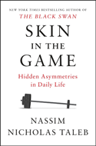
Skin in the Game

Hidden Asymmetries in Daily Life

By Nassim Nicholas Taleb
What's worse than taking advice from someone with a conflict of interest?
In this New York Times bestseller, one of the foremost thinkers of our time answers this question and others. He also redefines what it means to understand the world, succeed in a profession, contribute to a fair and just society, detect nonsense, and influence others.

Video MP3 Phone PDF

iPad Web M Sticks Kindle

