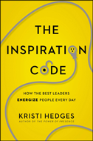
The Inspiration Code

How the Best Leaders Energize People Every Day

By Kristi Hedges
What EXACTLY do inspiring leaders do differently?
Kristi Hedges has spent years studying exactly what inspiring leaders do. She found that inspiring communication isn't about grand gestures. Instead, those who motivate us most do a few special things routinely, consistently, and intentionally. Learn what they do in The Inspiration Code.
"We all know what inspiration feels like, but often struggle to find it. Here's a book that can help, with plenty of practical tips for having more energizing interactions." - Adam Grant, New York Times bestselling author of Originals and Give and Take.

Video MP3 Phone PDF

iPad Web M Sticks Kindle

